System Requirements:
Win XP SP3,
Win 7,
Win 8,
Win 10
Applicable to:
DK-8-KZ(DK-8 PRO-5, JZ-5, JZ-6, DK-5 PRO-5), DK-8-FKZ,
DK-BL
1.How to install the software?
Step1:
Install the.net Framework 4 environment, If your computer already have a Microsoft .net environment, Win8 and Win10 have already install .net framework, you can skip it.
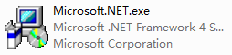

Step2:
Install driver
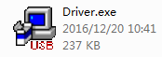
step3:
run this software
